Review of Smart and Green Interface Instrumentation and its Commercialisation

ABSTRACT
The clear differentiation of smart and green (S&G) instrumentation from either smart or green instrumentation is the departure point for this review. From this secure S&G standpoint there is a review of the latest S&G interface instrumentation, technology, test apparatus and process equipment based on collective experience of the partners in the COST MP1106 Action “Smart and green interfaces - from single bubbles and drops to industrial, environmental and biomedical applications (SGI)”. This review article will as usual in such a studies attempt to give an assessment of the importance of the various facets of this these instrumental developments and highlight and evaluate important current innovations and developments. However, beyond this subjective survey of the technologies based on reviewing the collective research experience of the partners in the Action, a graphical and objective overview will be presented. This objective overview of the individual aspects of SGI Instrumentation is based on a new methodology known as the “Advanced Meta-Review Process (AMRP)”. This very powerful approach gives a numerical view of the evolution of the field identifying the critical technologies a field and here flags the commercially important SGI instrumentation. Some effort is made then to identify the sizes of the market sectors that have been highlighted in this MetaReview and a reliable vision of developments in the next years is provided.

KEYWORDS
Smart; Green; Instrumentation: MetaReview: Commercialisation
NOTES TO MEMBERS OF WG4 AND COST MP1106 MEMBERS
The proposal is to deliver a Review Article of a type perhaps never produced heretofore and it is hoped that an article can be a genuine collaboration of COST members and will properly represents the expertise of the Action. The paper will be based in the first instance on the novel Advanced MetaReview Process that will objectively define the field of ‘SGI instrumentation’. The MetaReview approach is explained in an extract from a draft paper (Pasted below in Appendix 1) here and has been developed in the first instance by McMillan for the WG4 facet of our COST Action. The COST MP1106 review article on ‘SGI instrumentation’ will be written with a deadline to deliver a final draft before the end of July 2016.
Contributions are being sought NOW from COST Partners to be named authors of this Review Article who will draft material that highlights their own work to some extent be framed and given context of the most important research in their own field provided by the AMRP. The contributions will be asked to differentiate what is smart in the instrumentation that can be identified as green, and the related issue of what is green in the smart instrumentation that is relevant to their discussion. Example of this differentiation are given below as it is felt this approach could be is useful.
Lead authors of the review article are also sought who will not only work as a team to produce a final draft of the paper with the Chair of WG4, but will where necessary, compose material that is deemed to be missing from the collection of various contributions to deliver a coherent and rounded paper.
The text in the lead-out comments below are intended to highlight the sort of issues that can be included. The comments are based very much it should be understood from McMillan’s strengths. These comments are not meant to be comprehensive but nevertheless cast quite a wide net. The paper it is hoped will give this impressive review of the SGI Instrumentation and will also attempt to discuss the issues of commercialising ‘SGI Instrumentation’. Again, the COST partners are asked to volunteer to deliver this part of the paper, which if this is a significant part of the material, perhaps it could form Part 2 of this Review Article rather than being a mere component.
TEXT WITH LEAD-OUT COMMENTS FOR POSSIBLE ISSUES IN PAPER

CONTENT OF PAPER TO BE AGREED BY COLLABORATORS IN THE WRITING. MCMILLAN INTENDS TO PRESENT IN ATHENS AN AMRP EXCEL ANALYSIS AND HAVE FOR THOSE ATTENDING A WG4 MEETING THIS ANALYSIS FROM WHICH THE PAPER WILL BE DRAFTED.
- INTRODUCTORY COMMENTS TO HELP FRAME THE WORK
1.1 Recognising Smart, Green and ‘Smart and Green’ Instrumentation

What exactly is ‘smart’, ‘green’ and finally, ‘smart and green interface technology’? The approach to providing an answer to a series of questions. The first issue to address is what is ‘smart’ in instrumentation and technology in the general sense? Then, the corollary must be addressed of how this description apply specifically to interface science instrumentation. The same questions need to be answered sequentially then for ‘green’ instrumentation and finally for the centrally important combination of ‘smart and green interface science’. The paper will also on the basis of some relevant examples explore the difference between “smart and green interface instrumentation” and ‘green and smart interface instrumentation’.
Taking the first of these questions. A dominant trend over half a century in analytical instrument product evolution has been miniaturization which has led directly to today’s increasingly smart instrumentation. The age of microprocessors/mini instruments began in the 1970s, portable micro-instruments appeared in the 1990s and the Nouties step-by-step saw the introduction of new nanotechnologies into instrumentation products which is a development that continues to this day. There are numerous examples of such miniaturized smart technologies, but one example here will suffice to illustrate the type of state-of-the-art smart technology; hardware working and under control of systems employing nodal fiber connectivity exploiting both wireless telecommunication and software opportunities that flexibly and smartly address progressively a growing numbers of applications. Smart instrumentation and products are presently being developed at a rapidly accelerating pace and to give but one useful example here of a one such field the important advances in smart optics are perhaps the most relevant (adaptive optics, multispectral imaging ultra-imaging systems, smart simultaneous multicomponent detection, smart sample handling, chemometric software using fuzzy-regret algorithms, Micro-Electro Mechanical Systems (MEMS), self-powered wireless multiplexed working with cloud computing software, and other cutting edge technologies.); collectively a suite of approaches to deliver new and smart measurement solutions, capabilities and technologies are expanding in numerous fronts. The rule today is clearly that one size definitely does not fit all; here is the smart world of targeted technologies delivering optimised solutions for the user.
The traditional chemistry and biology laboratory is perhaps dying in front of our eyes. An intelligent instrument can be considered to be a special-purpose control system, in which a set of signals are processed to provide the measurement data while a further set signals is used to ‘control’ the local environment working to deliver a bespoke smart measurement or outcome. Software is a fundamental requirement in any smart technologies. Given a credible set of algorithms for the smart instrument, the next task is to embed the operation into specific hardware to deliver very specific smart solutions. The target for instrumentation companies is consequently progressively to hone down their technology to deliver applications solutions that are tailored intelligently and evermore specifically to the end user. There exist as a consequence of smart technologies related transformative research today, for example, in the development of such surface science probes as fluorescent proteins in particularly for fluorescence resonance energy transfer (FRET) applications, which are used to measure interactions between proteins in vivo. Research is spawned as a direct consequence of the appearance of new technological capability and we can talk about “smartly initiated research fields”. Indeed, a great number and range of fluorescent proteins are currently available for such research that is expanding to address the growing needs of cell biologists. The economic consequences of smart technologies must include these downstream calculations and here specifically surface science with its long history of the study of complex biochemical kinetics is of course a driver of smart applications research in instrumentation and is most definitely part on the upstream side here helping launch the smart technologies.
The second question is what is ‘green technology and instrumentation’, but here it is of course necessary to discuss this general issue in the context only of surface science. Advances in the fundamental understanding of molecular processes on surfaces over the past decades often fall clearly into the green domain. The developments of the molecular-level surface techniques deliver some of the most important green technologies for industry. New scientific insights provided by in situ experimental and theoretical techniques capable of characterizing surfaces and interfaces under working conditions and these are primarily fall into the category of green technology. The green technology is frequently not aimed primarily at the lab, but is developed for field monitoring applications for measurement and control. Consequently, these advances raise many complex green chemistry and biology issues, the requirement for new measurement standards and protocols, new thinking in engineering that delivers the green systems and most importantly green roadmaps. Green issues are ones that require socio political solutions that become drivers for technological advances which is a most important fact in modern Europe and its nation states. Green instrumental and technological targets include for example green health safety monitoring in the internal work environment; monitoring of air, water and land [Safety/Human Health/flora-fauna/Pesticides/Ecological]; waste disposal problems (dispersed / very toxic) that today are most clearly focussed on smart solutions moving forward to a circular economy with waste elimination; low energy systems which in our instrumentation/technology field translates into developing such technologies as lab-on-a-chip; and not to be forgotten, exploiting of nanotechnologies in both materials and analysis hardware. Importantly, for the COST MP1106 Action with several large companies contributing the importance of new production methods – BREF (eippcb.jrc.ec.europa.eu/)/low waste/efficient catalytic reactions here cannot be overestimated. These green solutions and technologies are of already of central importance in surface science but are of growing importance.
The most important question here is what exactly the key development issues, technologies and indeed application fields for ‘SGI instrumentation’? Acknowledging the obvious fact that SGI is a new concept and accepting what will emerge for this collaboration and recognising that this is an early stage of SGI evolution this analysis will of necessity be rather subjective. It is nevertheless important to make these calls in a review article. SGI technologies would exploit for instance such things as intelligent predictive control of technology to minimize both energy usage and pollution by for example by minimizing sample volumes and preferably analysis without any chemistry measuring directly samples; environmental scanning technologies; use of enhanced analysis techniques such as SERS and SERRS; exploiting technologies such as that offered by COMSOL for developing FEA multi-physics optimisation of technologies to ensure the absolute best possible chance of effective and indeed optimised operation; smart calibration to enable for example NIST referenced measurements to be used in large data bases for modeling the environment; cloud/parallel/grid computing for providing a powerful model of the environment; green sensors and particularly those with fiber connectivity that allows their flexible deployment and network connection to wireless/control systems; self-assembly, self-repair and importantly and frequently forgotten in instrumentation self-cleaning; ultra-control systems such as micro-positioners; hyphenated technologies and such.
The issue of SGI integration of technologies into the environment and society as these are required to deliver green solutions; nevertheless such technologies have associated and often what seems rather mundane issues but ones that nevertheless are crucial issues as performance (e.g. battery life, storage, and bandwidth), environment (e.g. heterogeneity, scalability, and availability) and security (e.g. reliability and privacy) all of which are incredible importance in our modern society.

**********************************************************************************

APPENDIX 1 Draft Paper (Extract only)
A collaborative exercise to establish the requirements for a proposed textbook in an emerging subject area using a new advanced scoping meta-review methodology

Abstract
An exercise was undertaken by members of the library staff at the Institute of Technology Carlow, (ITC), in collaboration with a former academic staff member to survey and evaluate extant review material within an emergent subject area – nanospectroscopy. Use of an advanced scoping meta-review methodology was employed in order to ensure that an appropriate mapping of this subject area was undertaken, to enable a qualitative and quantitative analysis to be undertaken in order to identify significant topics. This process was undertaken to ensure that a pedagogically coherent structure would be created to inform discussion of the preparation of multi-authored subject textbooks for early-stage researchers.

Background
The MetaReview project owed its origins in developing under the auspices of the European Union COST Action MP1106 in developing plans for the Instrumentation and Commercialisation Workgroup. Subsequently, there was a requirement was developed under the auspices of the European Union COST Action MP1302 for the production of a textbook. This paper is based on the COST MP1302 work but is derivative from the earlier work from the earlier COST Action. As the subject area of the proposed book – optical nanospectroscopy – is an emergent one, (from the wider and established area of optical spectroscopy), it was considered to be essential that a comprehensive review of extant literature within this new field should be undertaken in order to evaluate and identify the appropriate topics for inclusion within the proposed textbook. It was strongly believed that a coherence of structure would. As the production of the textbook would require multiple authorship, it was felt that the development of the coherent structure would ensure that strong editorial control could be exercised over the production of the material for inclusion. Furthermore it was strongly considered that coherency would encourage better material retention by the students, and for durability of the work.
It was therefore crucial that the literature review should inform the creation of this structure, and it was therefore considered that employment of the scoping review methodology might provide a suitable tool to accomplish this task. The task of undertaking such a rigorous survey of literature and other material in a relatively newly-developed area of science provided a unique opportunity for collaboration between academic and library staff and illustrates both a model for future collaborations and a template for scoping subject content for a variety of purposes.
The development of methodologies relating to literature reviews, and particularly scoping reviews appear to have occurred primarily within the areas of medical and social sciences. A search of a web discovery service, undertaken in January 2015, at the Institute of Technology Carlow, for the keyword phrase “scoping review” retrieved a total of 1,457 peer-reviewed journal articles. An analysis of the subject terms related to these articles revealed an overwhelming predominance of terms related to medical and social sciences and very little reference to other scientific disciplines. The emphasis on the using of such review type within the social and medical sphere is also reflected within literature discussing the development of scoping review methodologies. Arksey and O’Malley [2] noted in 2005 that a wide range of terminology had been produced to describe various kinds of review, and clearly emphasized the difference between a systematic review, (to focus on specifically defined research questions, possibly using a limited range of sources), and a scoping review, (which may be used to encompass a much broader subject enquiry using a non-qualitative range of literature sources). In addition they proposed a methodological framework for undertaking a research-focused scoping study. Later studies by Armstong et al.[3] and Levac, Colquhoun and O’Brien [4] re-examined the use and methodology of scoping studies, with the former noting that such work may have applications beyond simply providing a basis for future systematic review work.
A more recent development of the scoping review has been discussed by Sarrami-Foroushani et al. [5] where the concept of a ‘scoping meta-review’ was put forwards as a development of the scoping methodology to further assist in the review of an emerging new field of an interdisciplinary nature. This approach provides a contrast to previous discussions of the use of scoping studies which have tended to concentrated on the more traditional role of the methodology in support of specific research questions, and therefore offered a suitable framework for undertaking a large-scale review of the required subject area, and the subsequent classification and analysis of results to inform the development of the proposed textbook’s pedagogical structure.

- The Review Process
The review process was undertaken using the following steps:

- Initial searching of relevant information sources to identify review articles on nanospectroscopy to identify potential topics and subtopics likely to be considered for inclusion in the subject matrix, [Figure 1.], created to map the area of interest.
(II) Analysis of review articles and inclusion of relevant ones in the subject matrix in order to establish a ‘weighting’ for topic importance.
(III) A second round of searching to identify general articles
(IV) Additional searching for relevant textbooks and tutorials

(V) Population of the subject matrix with further relevant material (textbooks/tutorials)

(VI) Statistical analysis and ranking of subject matrix to identify likely topics and subtopics to identify the essential topics and subtopics for inclusion in the proposed textbook. [Figure 2.]

A second iteration of the analysis process was undertaken focussing on the tutorial material in order to inform the process of developing a series of complementary online tutorials to support the textbooks.

  - The subject matrix
The preparation of the initial subject matrix was undertaken by a former Institute of Technology Carlow academic and co-Chair of the COST , Dr Macmillan, who has expertise in the field of spectroscopy – this was populated by known topics in this field following discussion amongst academic experts to identify a likely list of subtopics, ranging from the general to the particular, which were considered to be likely candidates for inclusion in a review of extant material in the subfield of nanospectroscopy.

Figure.1 Example of subject matrix
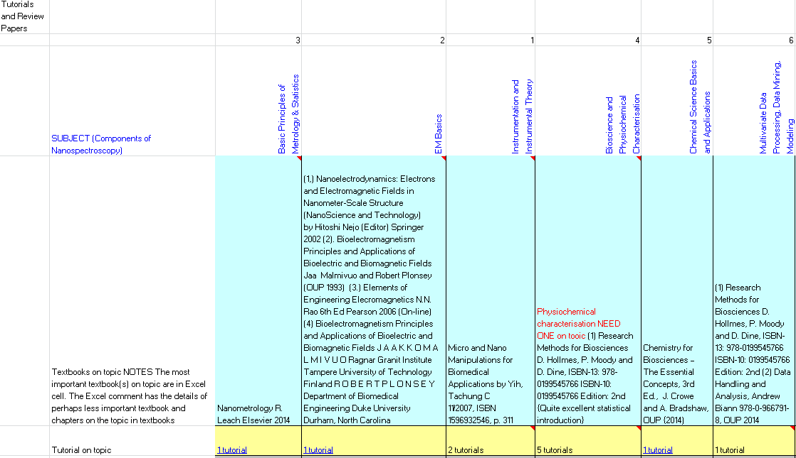

Once the initial matrix population was completed, extensive searching of the ITC Library’s online electronic resources was undertaken by Dr Macmillan in collaboration with two members of the library staff to identify review articles which related to the listed topics. For the purposes of this article a review article will be defined as one which can be seen to ‘sum up the current state of research on a particular topic’ [6]. Although initial searches established that research papers began to appear in the early 2000’s, a publication date of 2008 was established a start point which from when a manageable, but extensive body of literature could be examined. The analysis of search results enabled appropriate modification to the list of sub-topics being mapped in the subject matrix to be achieved.

  - The search process
ITC Library online information resources were used to search for review articles within the specified topics. This exercise presented significant challenges – attempting to retrieve only review articles via the Institute’s Web Discovery Service, (Summon), proved to be difficult. The Web Discovery System’s faceted filtering did not provide an adequate mechanism to isolate review articles from a larger result set. Attempts to use keyword combinations also proved to be less than satisfactory – this may be due to the variety of terminology which may be used to describe a review paper, e.g. ‘review paper’ ‘literature review’, ‘review article’ and the complications of excluding ‘review’ when used in other contexts, e.g. ‘book review’.
Searches undertaken through specific online databases – ScienceDirect and Web of Science proved to be far more fruitful, and provided clear identification of review articles, (Science Direct by labelling search results, Web of Science by offering a search results filter for review articles). One constraint put in place by reliance on ScienceDirect was the restriction to articles published by Elsevier, however the extension of searching to the Web of Science service successfully circumvented this obstacle.
Further iterations of the search process were undertaken in order to identify refereed papers and more general articles, and also to identify previously published books on any aspects of nanospectroscopy. As a proposal had been made that a series of online tutorials would be created, a final round of searching was undertaken to locate any related online tutorials.
The search process to identify general and refereed articles followed the same path as that for the review articles, but a comprehensive and systematic process to identify existing textbooks entailed the casting of a wider net: interrogation of much broader range of online resources had to be undertaken. Almost inevitably the major online monograph resources, for example, the Library of Congress, the British Library, OCLC Worldcat, Google Books, provided primary sources of material, further checking of the local ITC web discovery service, (where the ability to filter results as books or eBooks proved to be invaluable).
The final element of the search process – location of tutorials – combined the identification of tutorial material in print form, with interrogation of Google to locate online material in a variety of formats, (html pages, .pdf files) and on a mixture of platforms, (education and commercial web sites, YouTube). The setting of criteria to define what constituted an online tutorial of satisfactory quality proved to be an exacting task as examples were found ranging from one page pdf files to multi-step interactive programmes – ultimately this was a judgement to be left to academic expertise.
On completion of the extensive search exercise, complex analysis of results was undertaken to evaluate results and to full develop the subject matrix. Analysis of the review articles allowed a clear path of development within the field of nanspectroscopy with a 529% increase in publications found in Web of Science during the period 2004 – 2009, with a concomitant growth of identifiable topic subdivisions of the field from 12 to 19. Intriguingly the results post-2009 actually reduced even though a larger cohort of researchers were now active within the field. A graph [figure 2.] of results illustrates analysis of the review and general article publication of the field of nanospectroscopy within the period of interest.

[Figure 2.]
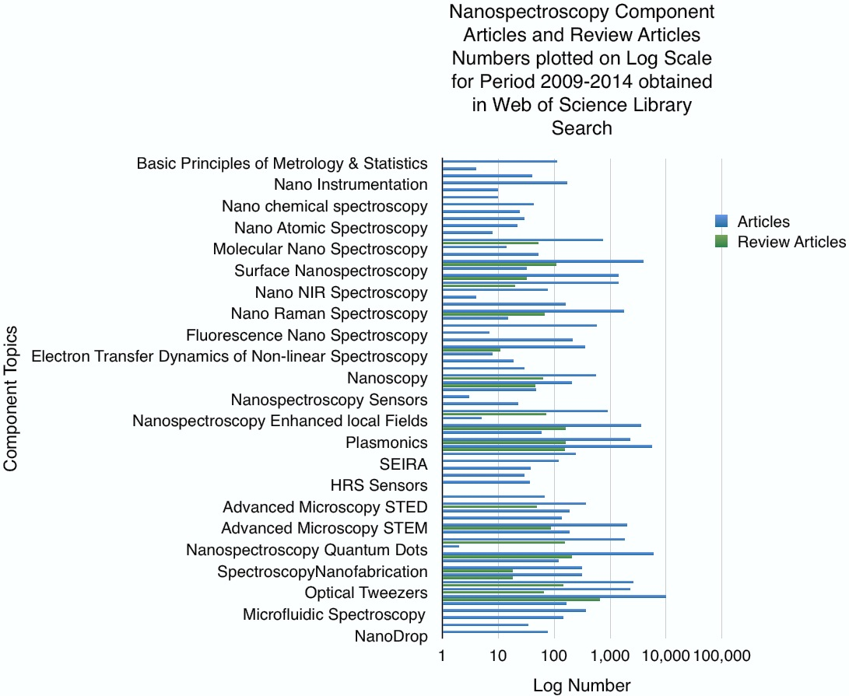

2.0 Completion of the Subject Matrix
The last component of the scoping exercise was, in many respects, the most complex – the quantitative analysis to identify the nature of topic expansion illustrated by the material which had been harvested during the search process – was followed up by full population of the subject matrix to complete the mapping of the field of nanospectroscopy. Once the population had been satisfactorily completed, the task of ordering the matrix to reflect the full mapping of the field and to establish the potential structure for the proposed textbook could begin : analysis of the number of articles retrieved in tandem with the increase/decrease of publication in subtopics over the specified period gave a general overview of the likely topics for inclusion. The ordering of subject matrix was further enhanced by colour coding to visually highlight subtopics and offer a ‘weighting’ in terms of relative importance, (e.g. ‘hot topic’, ‘industrial topic’ etc.) [Figure 3.].

Figure 3. – example of colour coding ‘weighting’ of matrix.
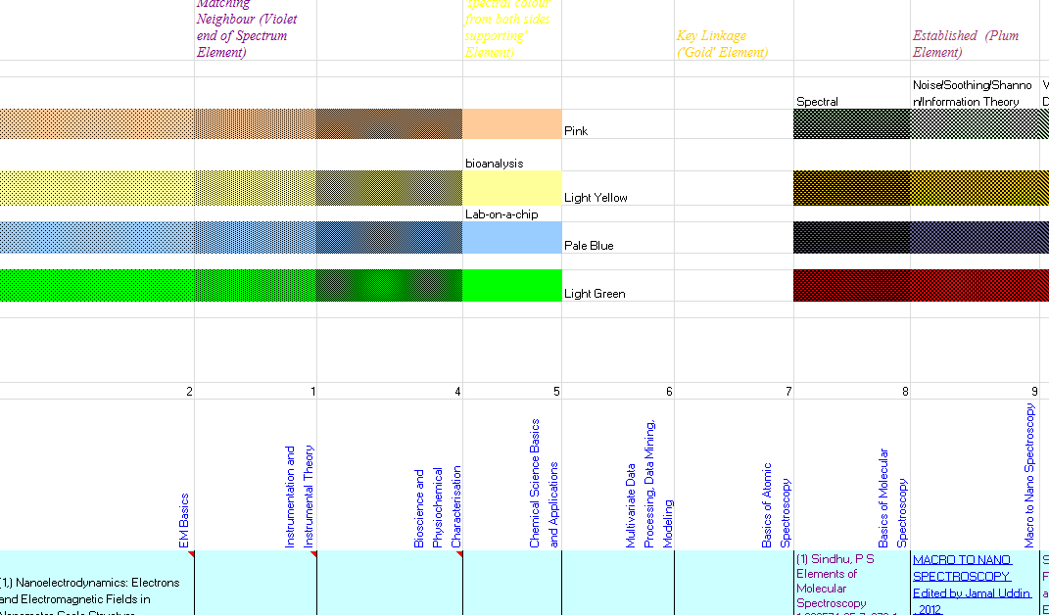

Remainder of paper is not relevant

Chatterjee P, Smart Wireless EDN I MARCH 1,2012

